**Requirements:**

Make a foreign key relation between the two tables and data should be entered in “SM30” only and don’t use any standard data elements.

Note: Create the TMG for both tables.

Agent Table:

|  |  |
| --- | --- |
| Agent code | CHAR |
| Agent name | CHAR |
| office | CHAR |
| Tel no | CHAR |

Customer Table:

|  |  |
| --- | --- |
| Customer name | CHAR |
| Date of travel | DATS |
| Dip point | CHAR |
| Arv Point | CHAR |
| Agent Name | CHAR |
| Reservation No | NUMC |
| Seat No | NUMC |

**Solution:**

**Step-1:**

Go to **SE11** and create a one new table. Table name should start with **“Z”** or “**Y”.**

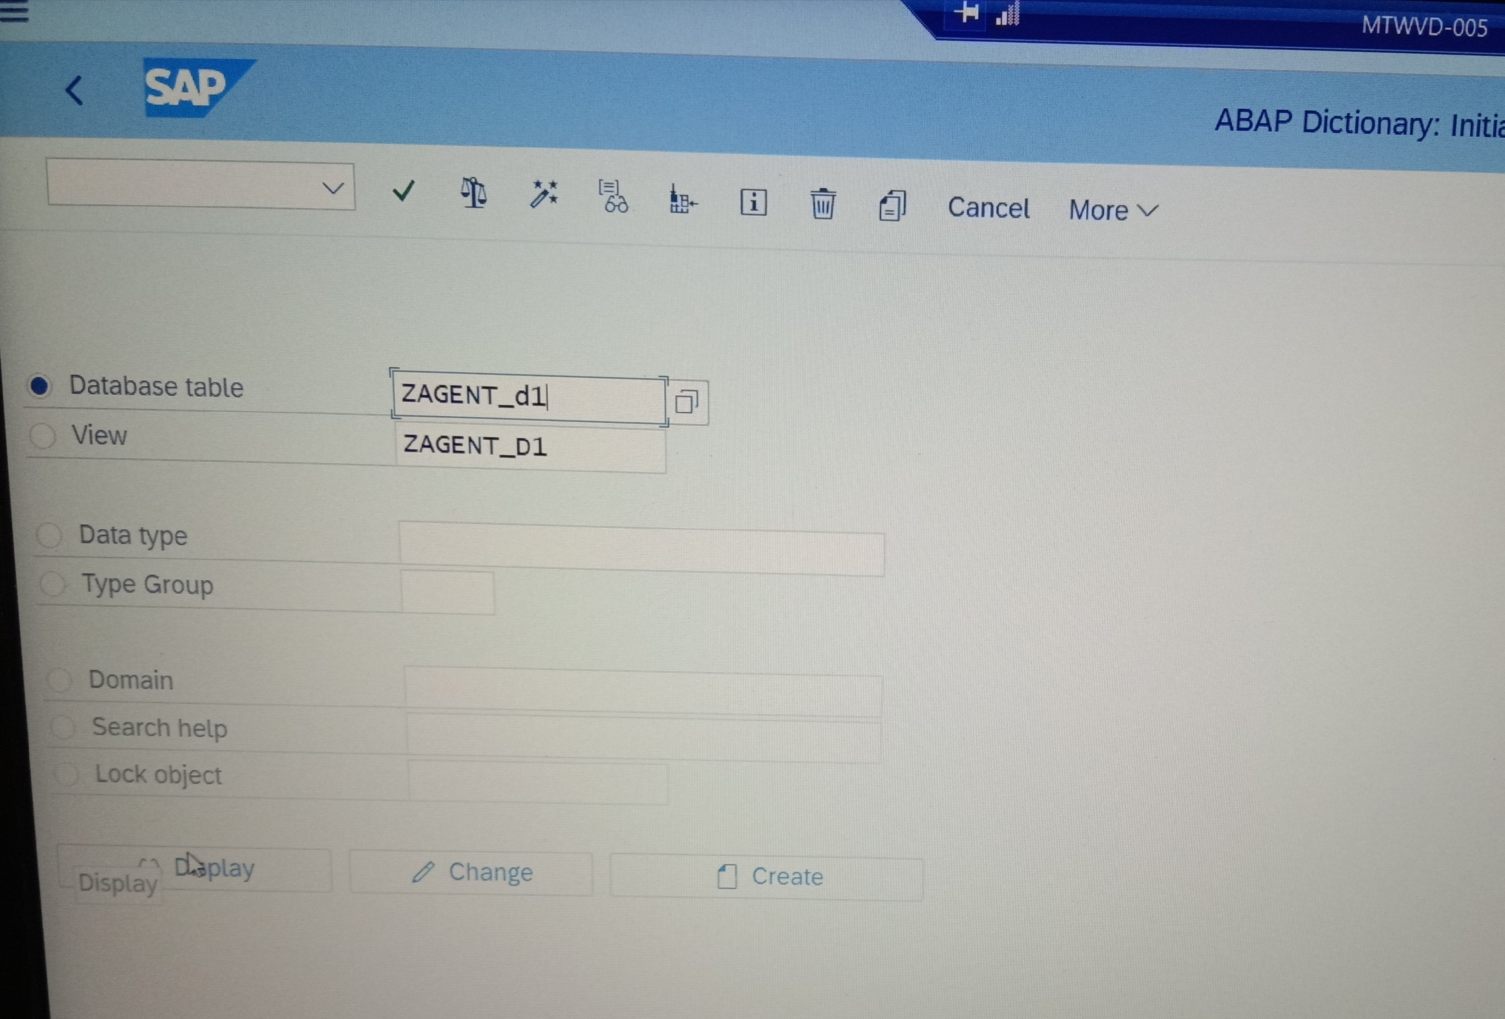

After giving the name click on the “**Create button”**.

**Step2:**

* After creating the table with “Zagent_d1 and Zcus_d” write short description of table.
* select the delivery class as “A” and set the display view maintenance as “display view maintenance allowed”.

**Step3:**

Enter the fields names of the table without standard data elements.

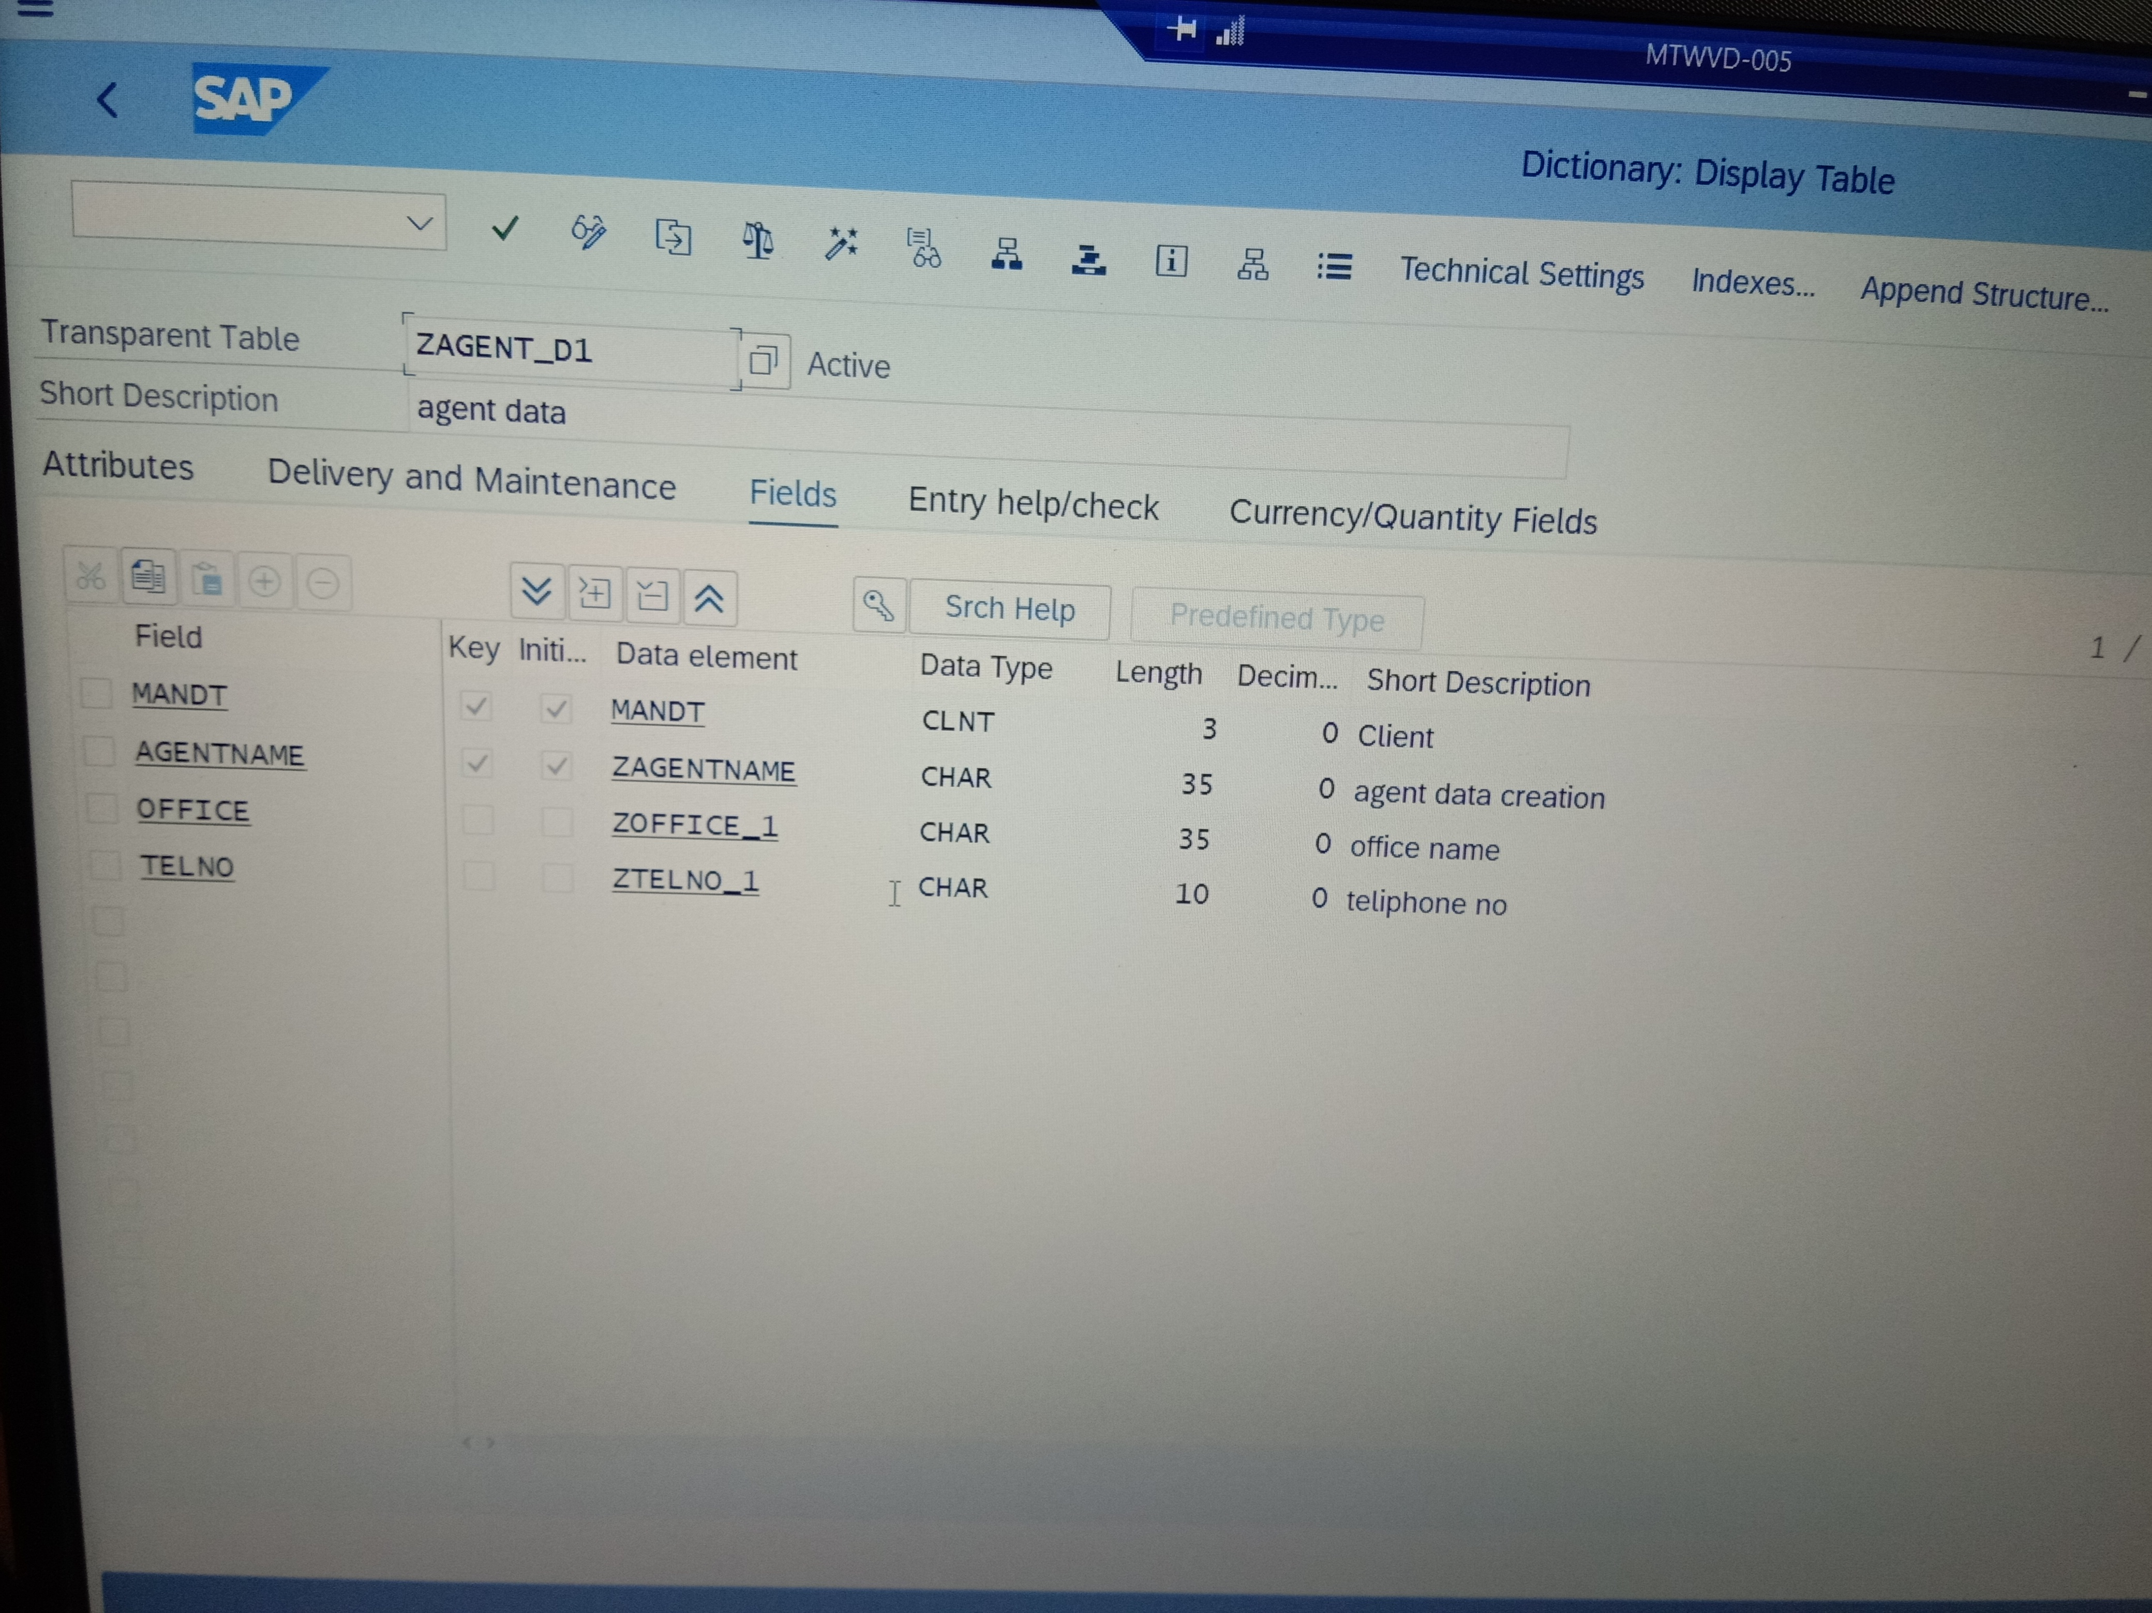

* enter the fields and create new data elements. And after the completion of fields entering in both tables save the table.
* Go to the “Technical settings” select the data class as “APPL0” and select the size category as “0”.

**For enhancement category go to:**

* More> utilities > select the enhancement category as deep enhanced.
* After click on the activate button and click on the continue then, and the table will be activated.

**Step4:**

For TMG go to:

More > utilities > select TMG

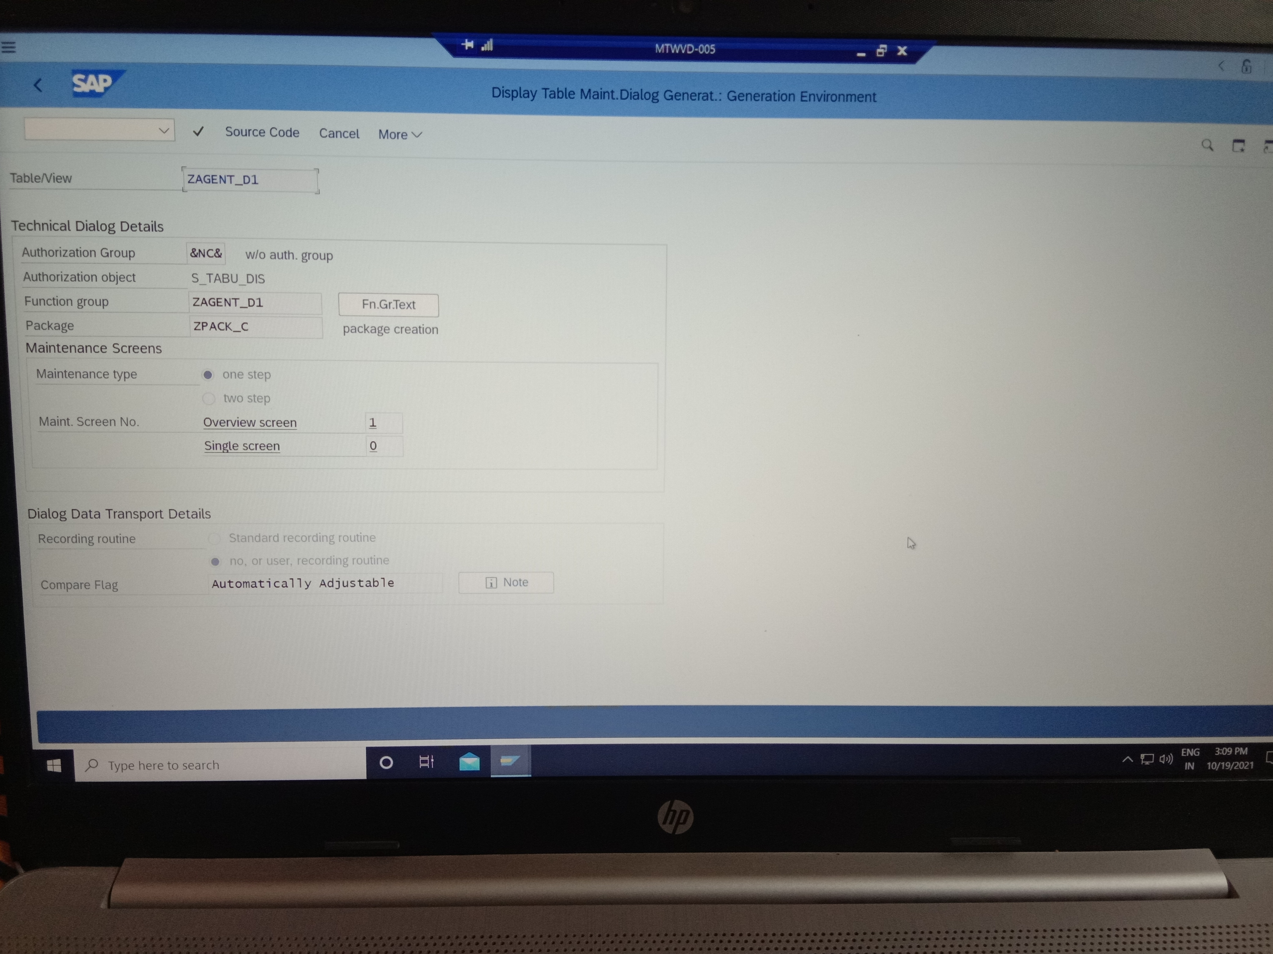

After completion of TMG creation we want to create entries through SM30.

**Step5:**

For entering the new records into the table Go to SM30 and screen will be displayed this

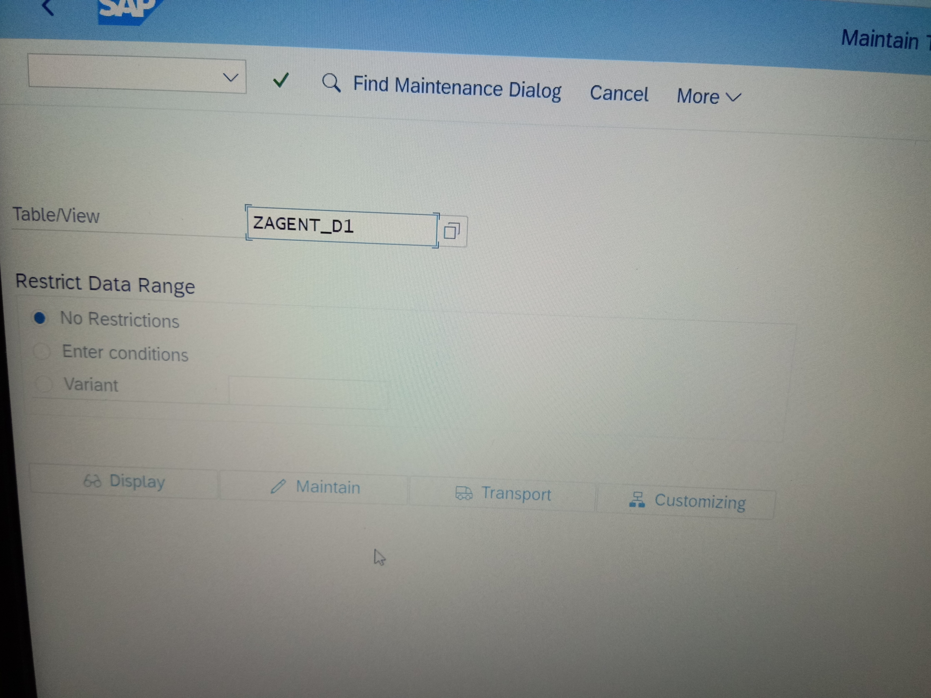

And click on the maintain button and entering the new records

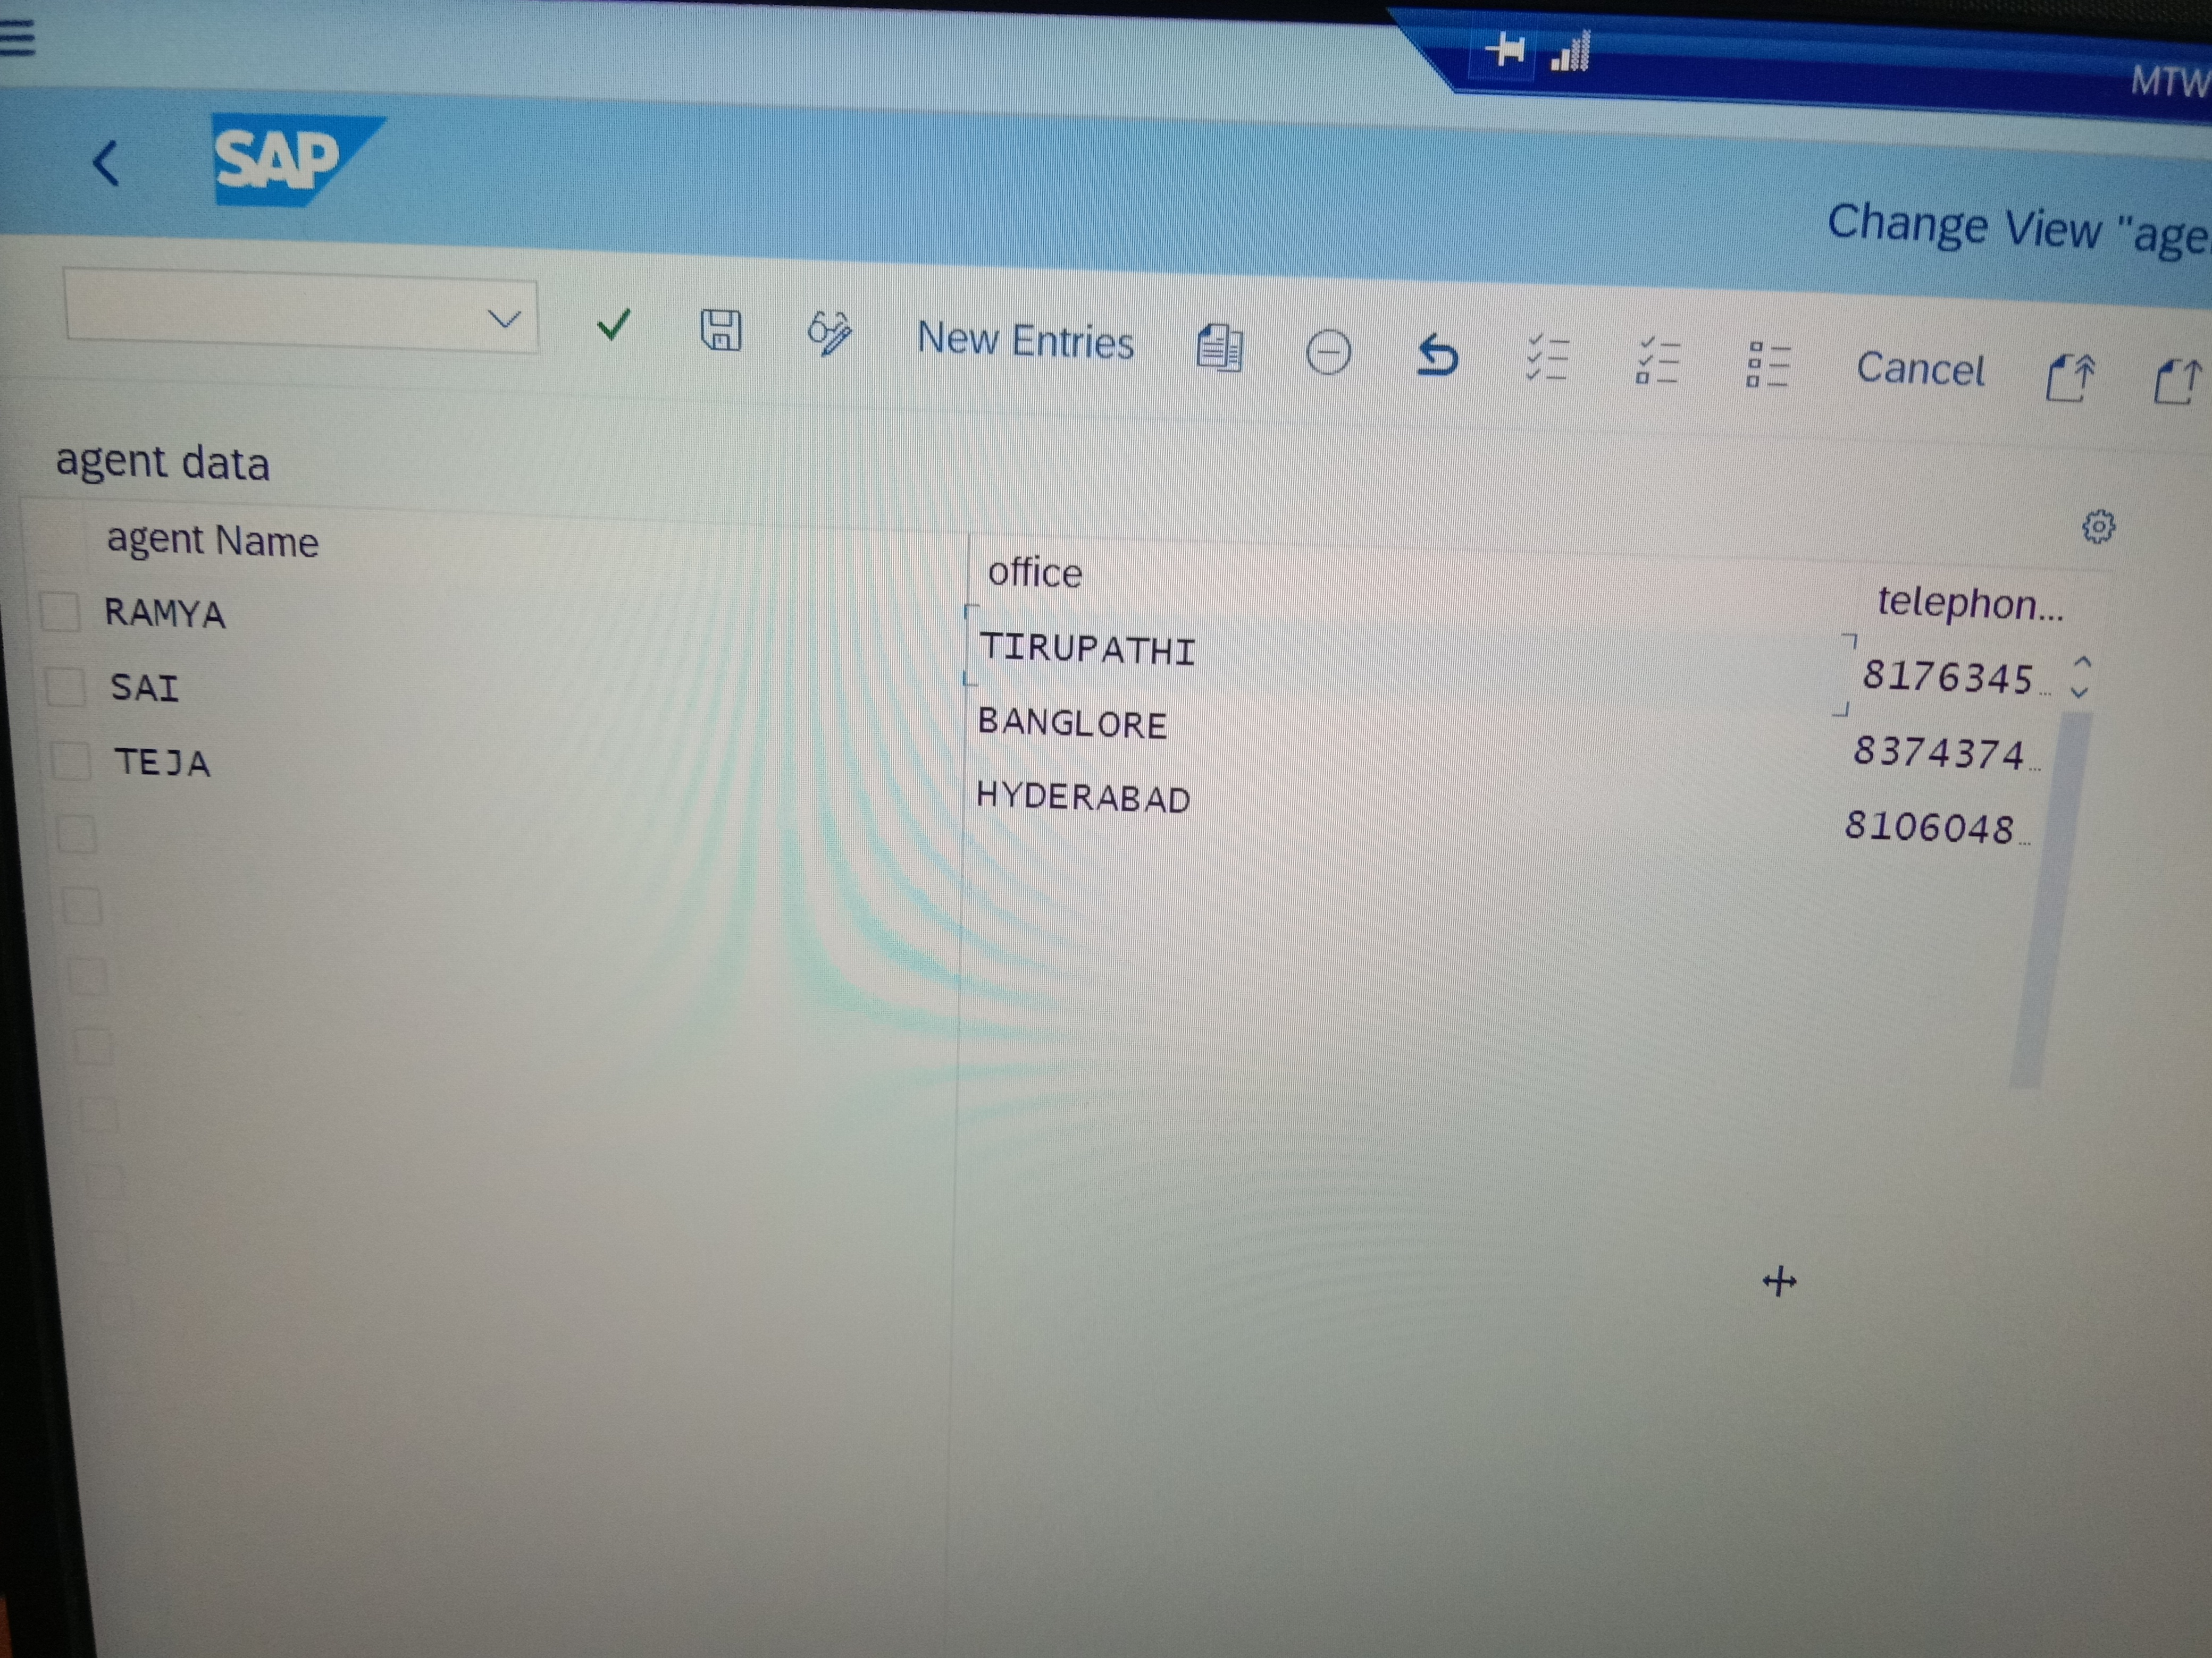

* And after the completion of records enter save button those records can see our table.
* After completing the table creation then we want to make a foreign key relation for that we go to agent table.

**Step6:**

* Agent table: customer table:
* Agent Name: agent name
* We want to make relation between agent name in agent table and agent name in customer table.
* So, click on the agent name field in customer table and click on the foreign key button
* type the agent table name in check table and click on the generate proposal button the screen will display like this
* click on the copy button

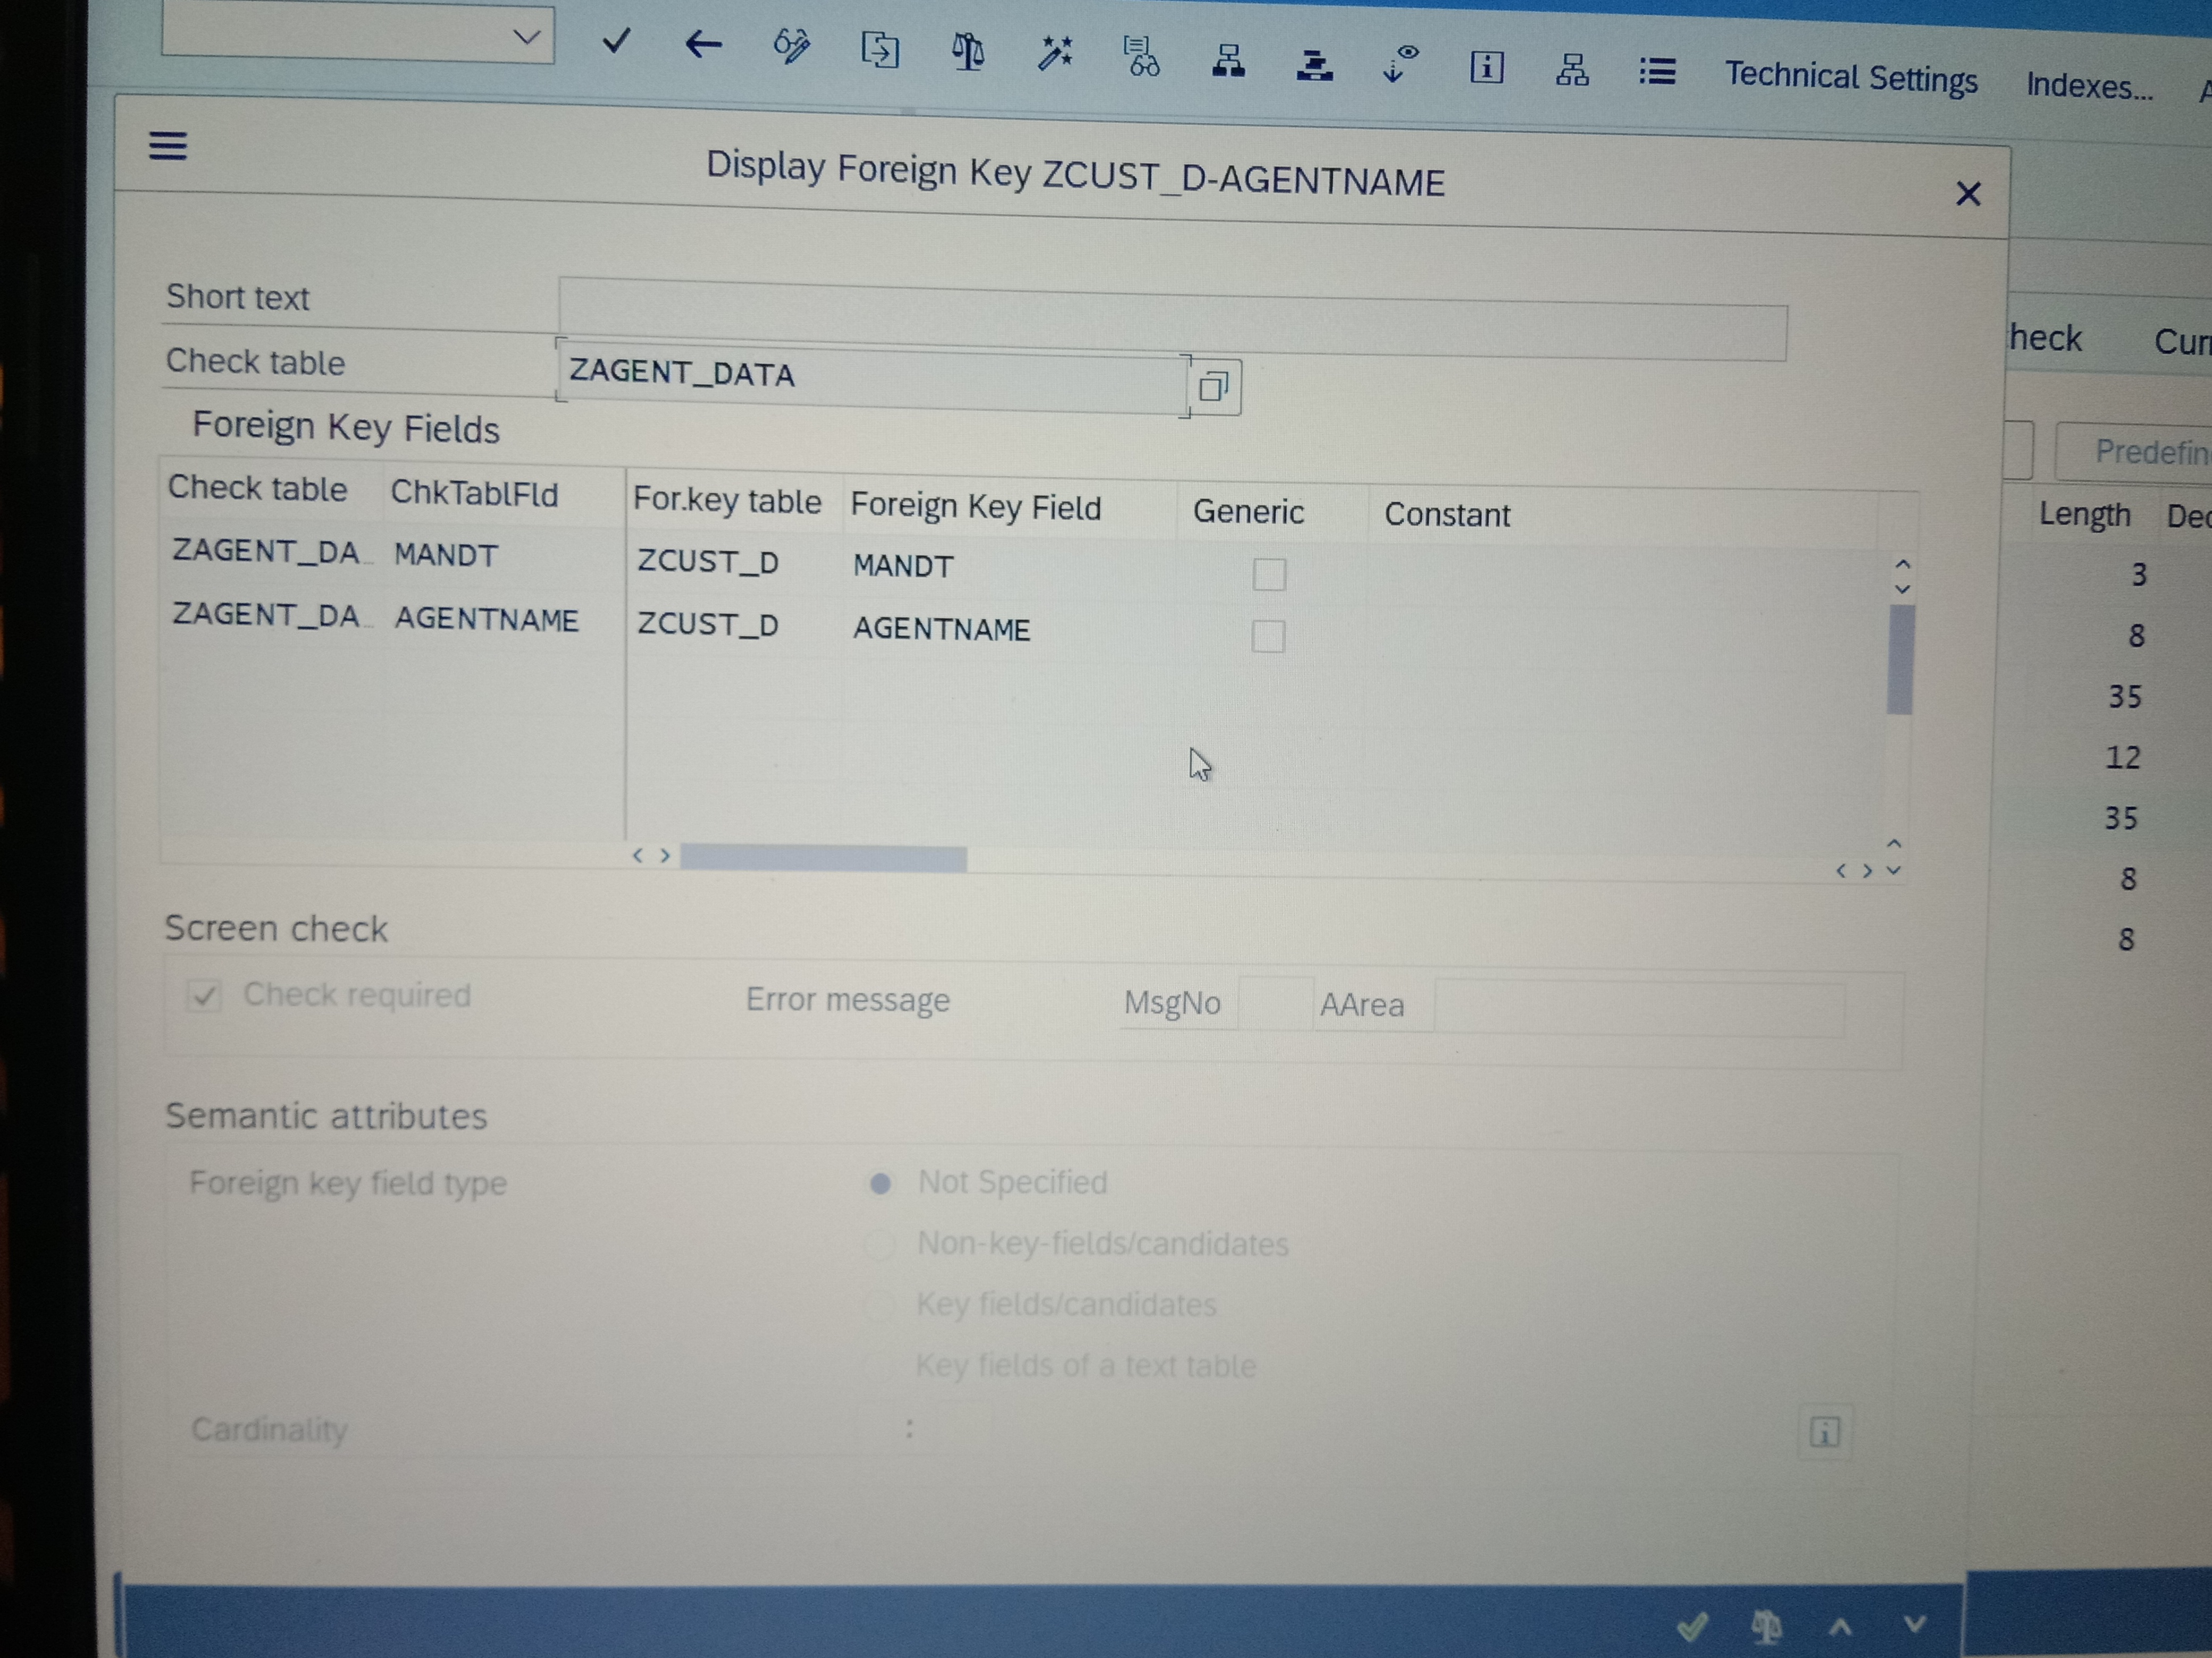

After this our foreign key relation will be completed and we will see the output of foreign key relation

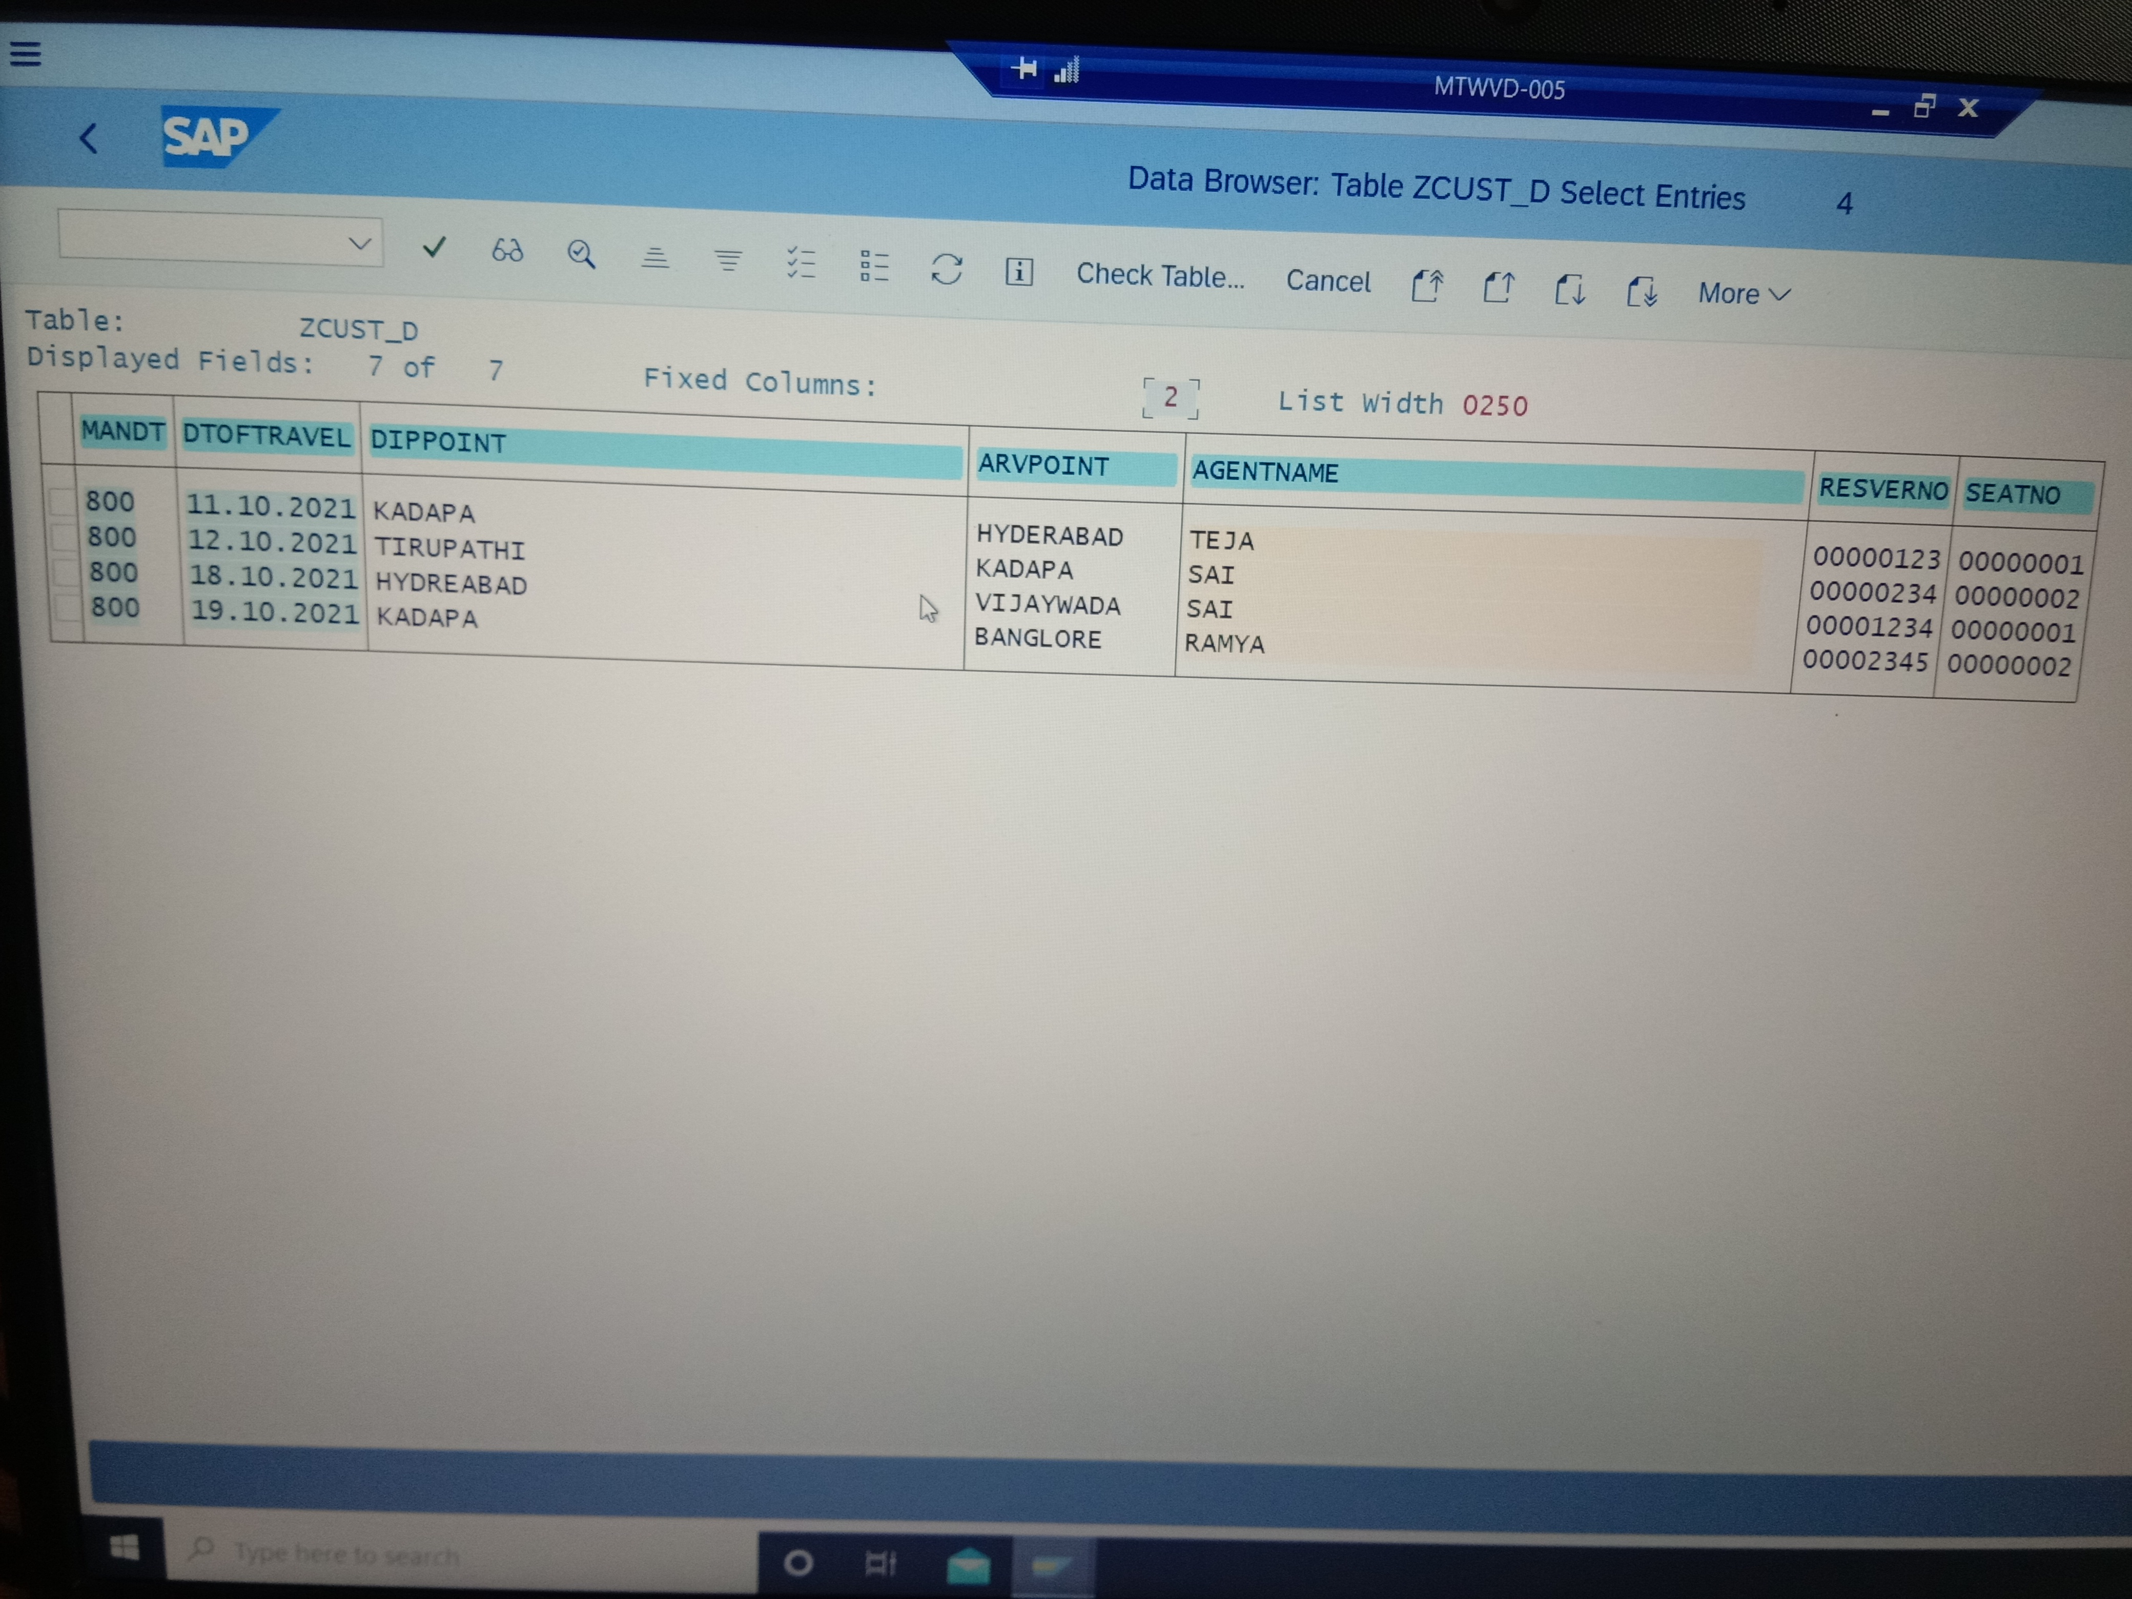

and if we want to see which table is check table , then click on the check table 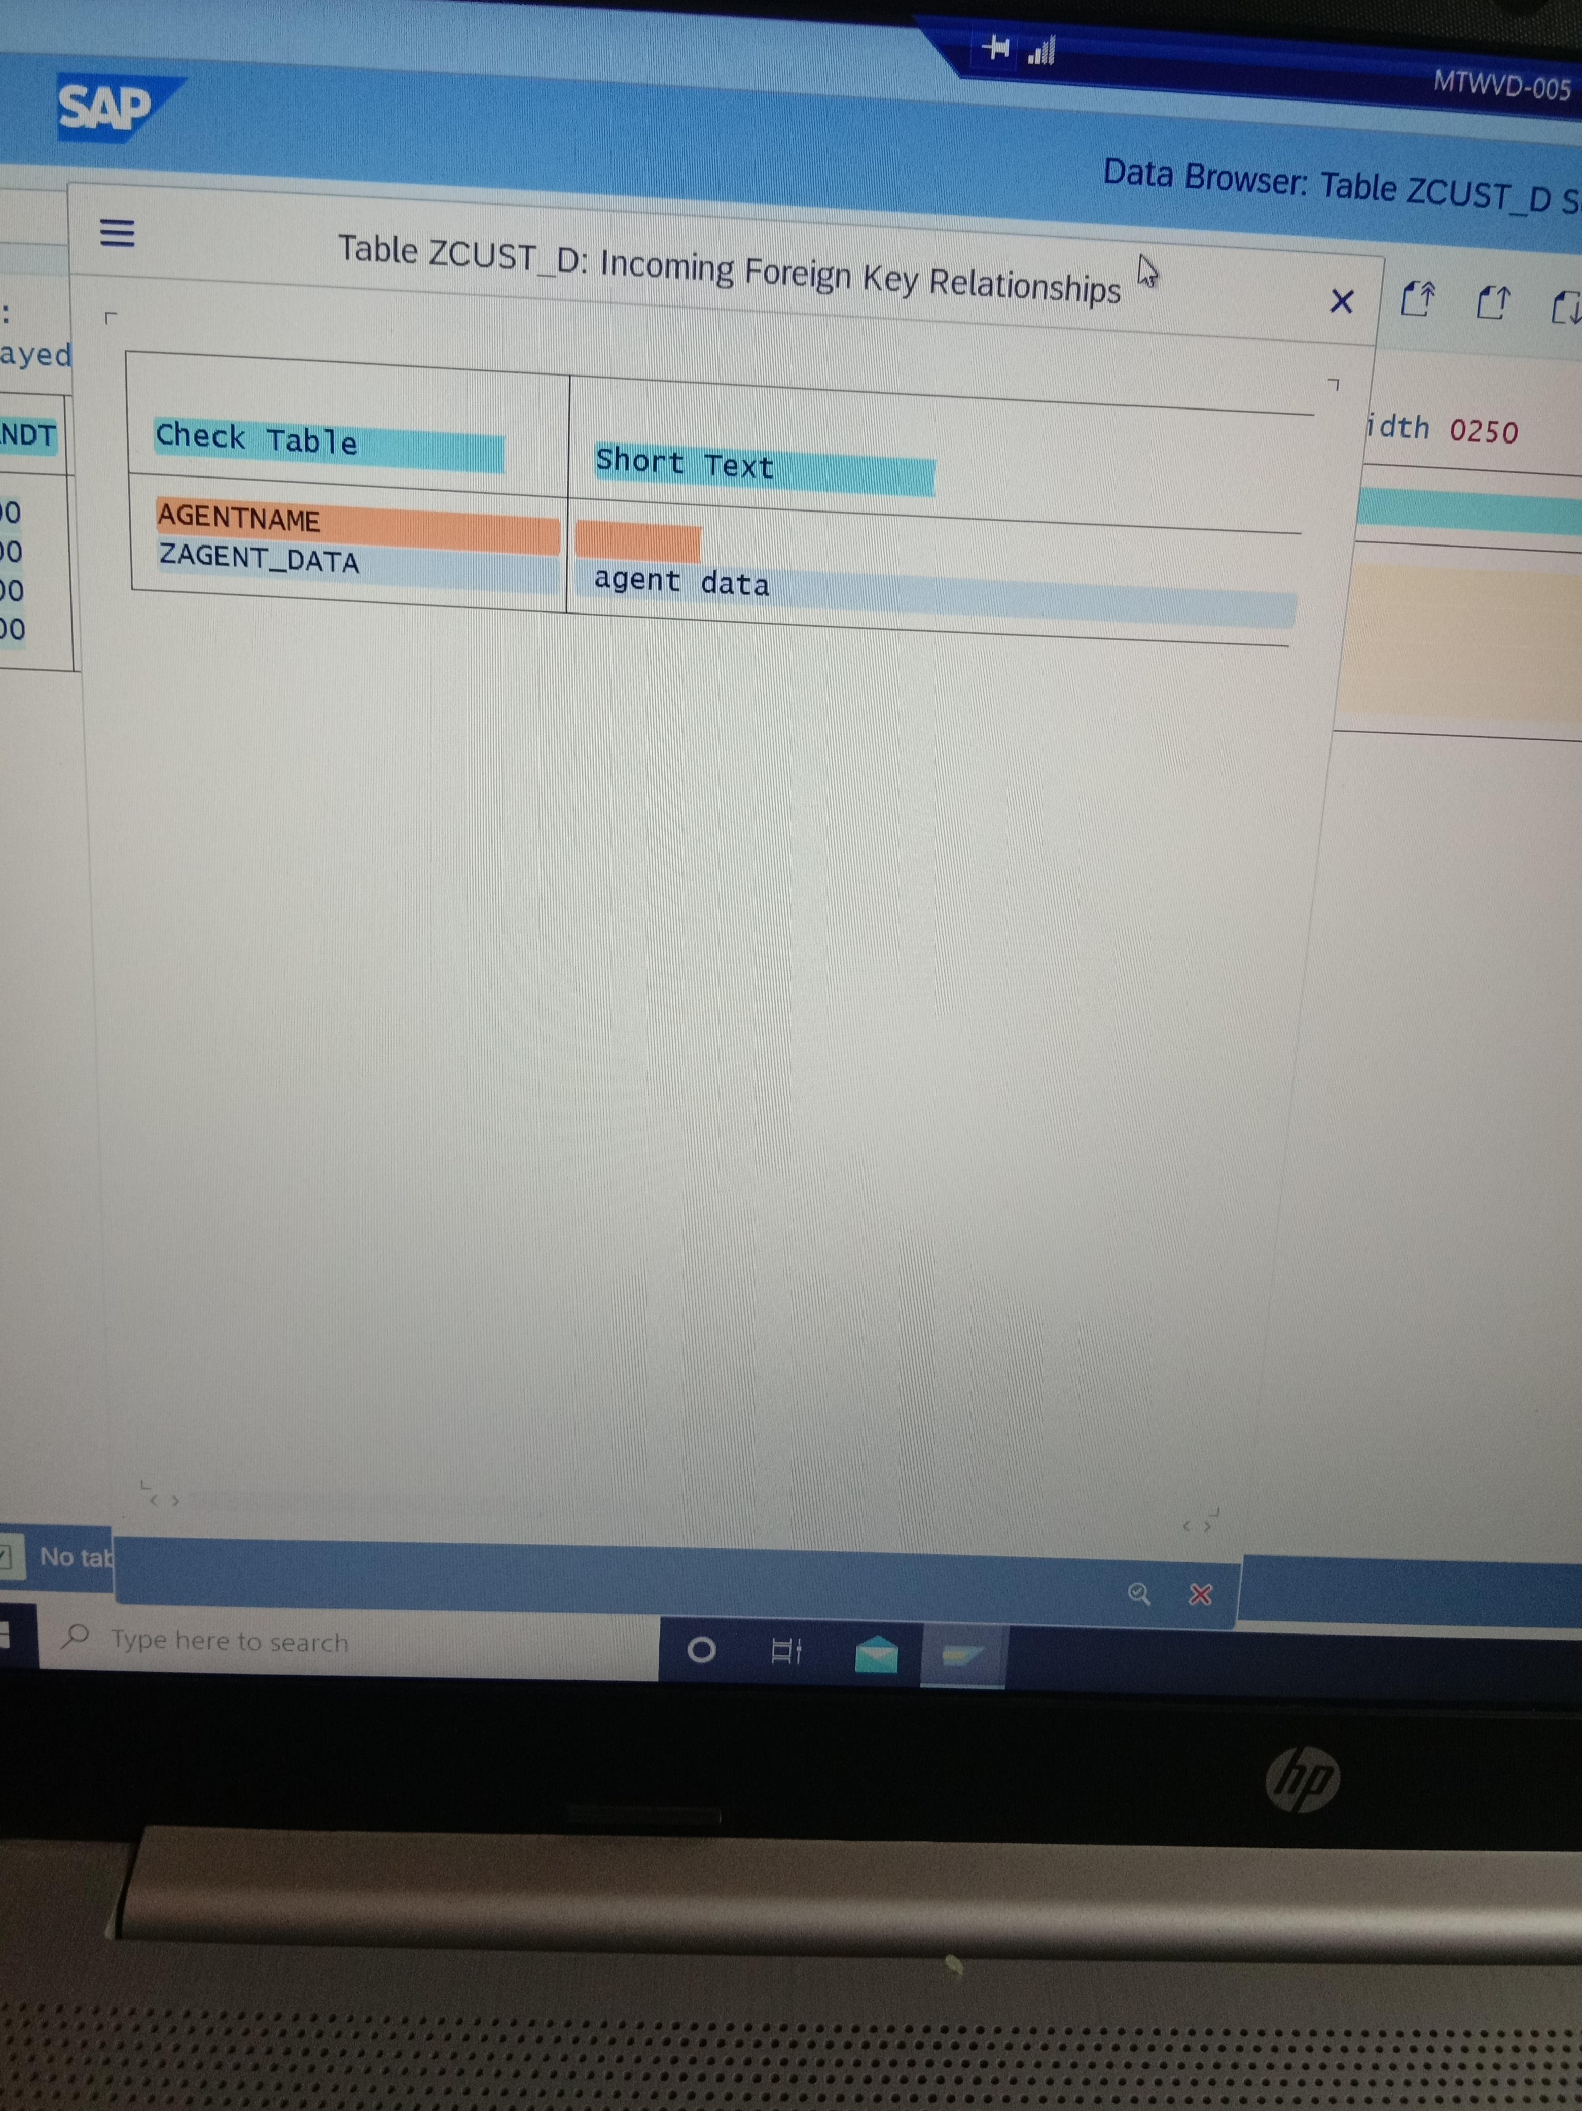

table button in the screen that the agent table is check table.